Iris Species (practice for unsupervised learning)
Source: https://www.kaggle.com/datasets/uciml/iris
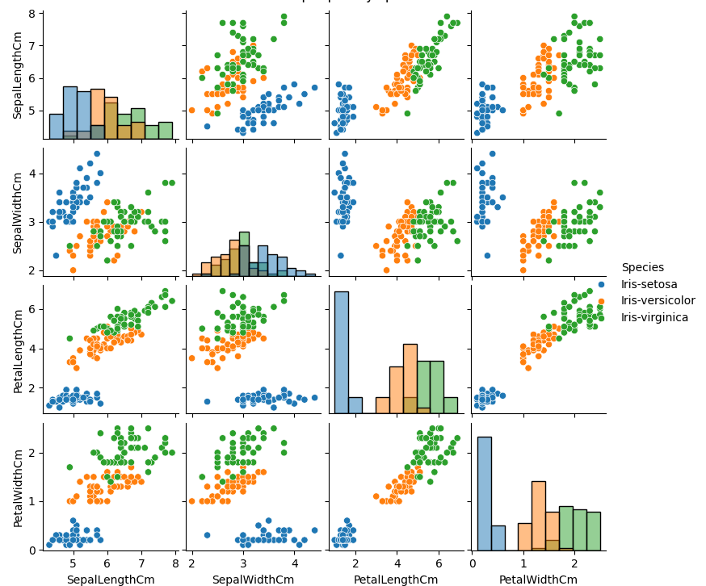

Petal length & width show clear separated modes
Sepal length & width show more overlapping regions, but still show separation -> weaker individual discrimination
- Overall, based on this scatter plot, PCA might be sufficient to use
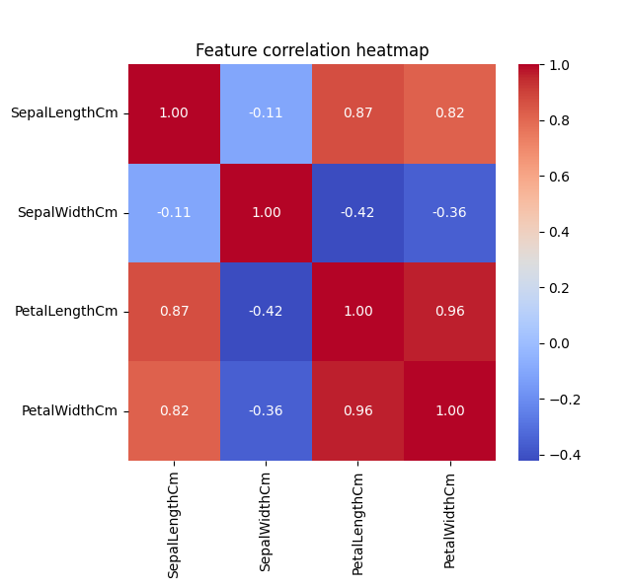
Petal length and petal width are highly positively correlated (≈0.96), sepal length also strongly correlated with petal length/width
- High correlation → PCA will capture most variance in first 1–2 components, so DR is meaningful

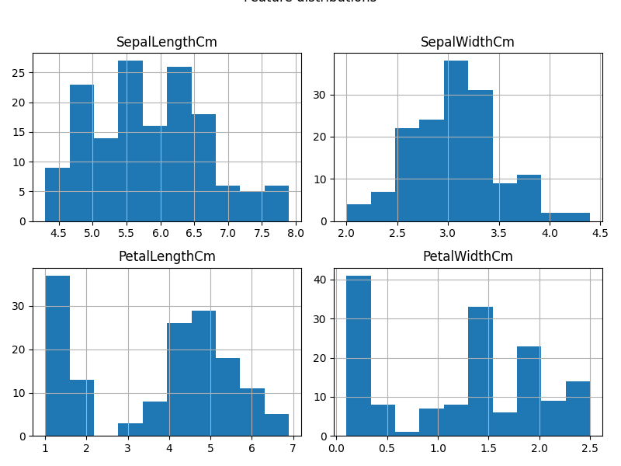

PCA (try 2 components at first)
Explained variance ratio: [0.72770452 0.23030523 0.03683832 0.00515193]
Cumulative explained variance: [0.72770452 0.95800975 0.99484807 1. ]
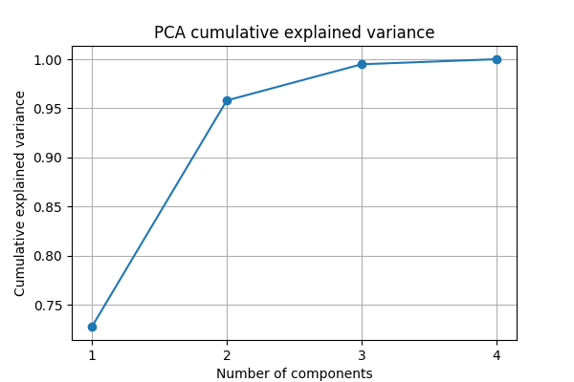
- PC1 alone captures about 73% of the total variance;
- PC1+PC2 capture ~96%, so PC2 is enough
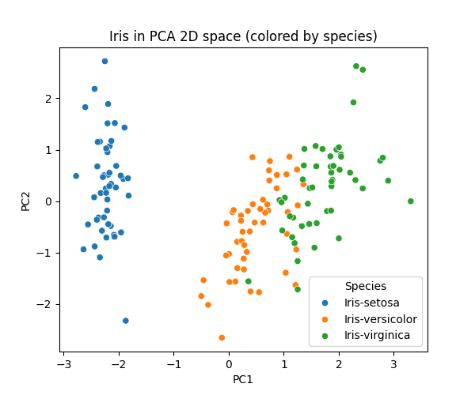
- Iris-setosa forms a well-separated cluster on the left; there is a large margin between it and the other species.
- Iris-versicolor and Iris-virginica overlap in the middle/right but are still roughly separable: versicolor sits between setosa and virginica, which lies furthest right.
- Overlapping areas for Iris-versicolor and Iris-virginica will cause K-mens and logistic regression to struggle
  - K-means assign points to nearest centroid in Euclidean space, but for the overlapping areas, points are almost equidistance to the centriod -> lower ARI (adjusted rand index, like accuracy)
  - Logistic regression learns linear boundries, Points near that boundary have similar probabilities for both classes; slight variation in features or training data will lead to misclassification

K-Means Clustering
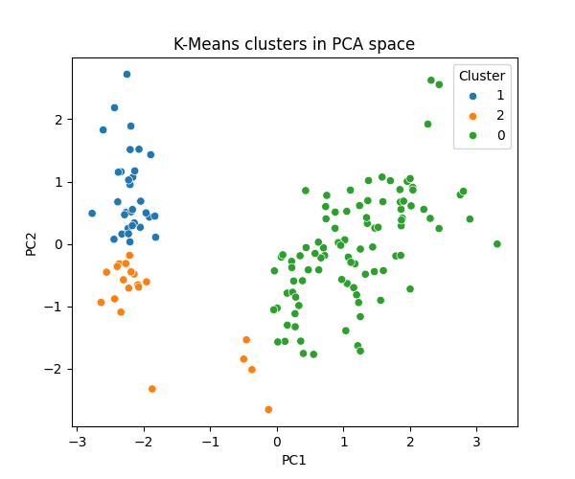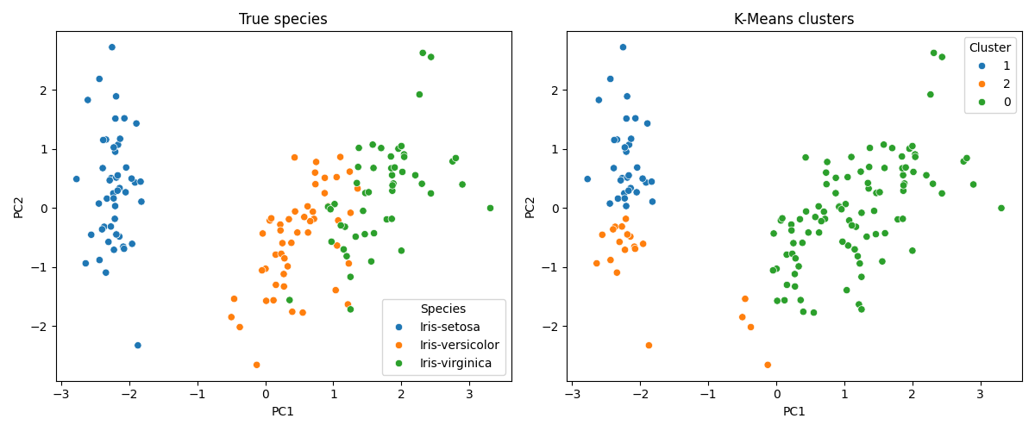

Silhouette score: 0.4787241921049546
ARI vs true species: 0.4289511167236898
- Setosa: perfectly separated and correctly captured by one cluster (cluster 1).
- Versicolor vs virginica: their regions overlap, and K-Means splits this area differently from the true boundary, leading to mis-grouped points.

To improve the ARI:
1.K-means using only petal features
[reationale]:
  - petal length/width separate species much more clearly than sepal features
  - Sepal features add noise and redundancy; clustering on all 4 dimensions may pull centroids slightly in the wrong direction.
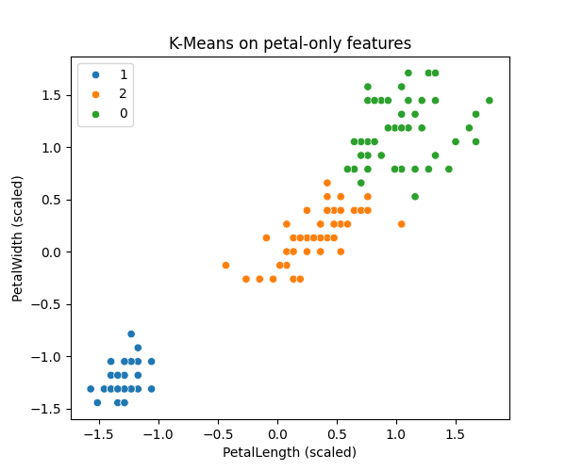
silhouette 0.67
ARI 0.89
Three clusters form clean, well-separated blobs:
  - One cluster at low petal length/width (setosa-like).
  - One in the middle (versicolor-like).
  - One at high petal length/width (virginica-like).
[results analysis]:
- Since we have prove that petal length and petal width are the most discriminative features; sepals add noise and redundancy
- By restricting K-Means to these two dimensions (after scaling), the algorithm clusters directly on the biologically meaningful axes, removing confusing sepal information
- Distances between points now reflect species separation more accurately

2. K-means on PCA space
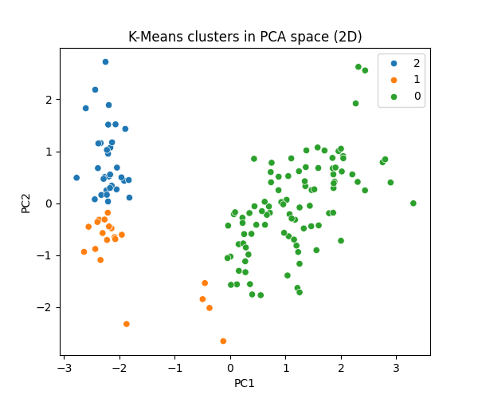
silhouette 0.52 (slightly better than 0.48) [better cluster separation]
ARI 0.43 (same as all-features).
[only modest improvement]:
- PCA 2D already captures a mix of sepal + petal information, compressing redundant directions and scaling them, so distances are somewhat cleaner.
- K-means in PCA space still keeps some sepal influence and the intrinsic overlap between versicolor and virginica, so ARI remains the same as all-feature K-Means.

3. GMM in PCA space
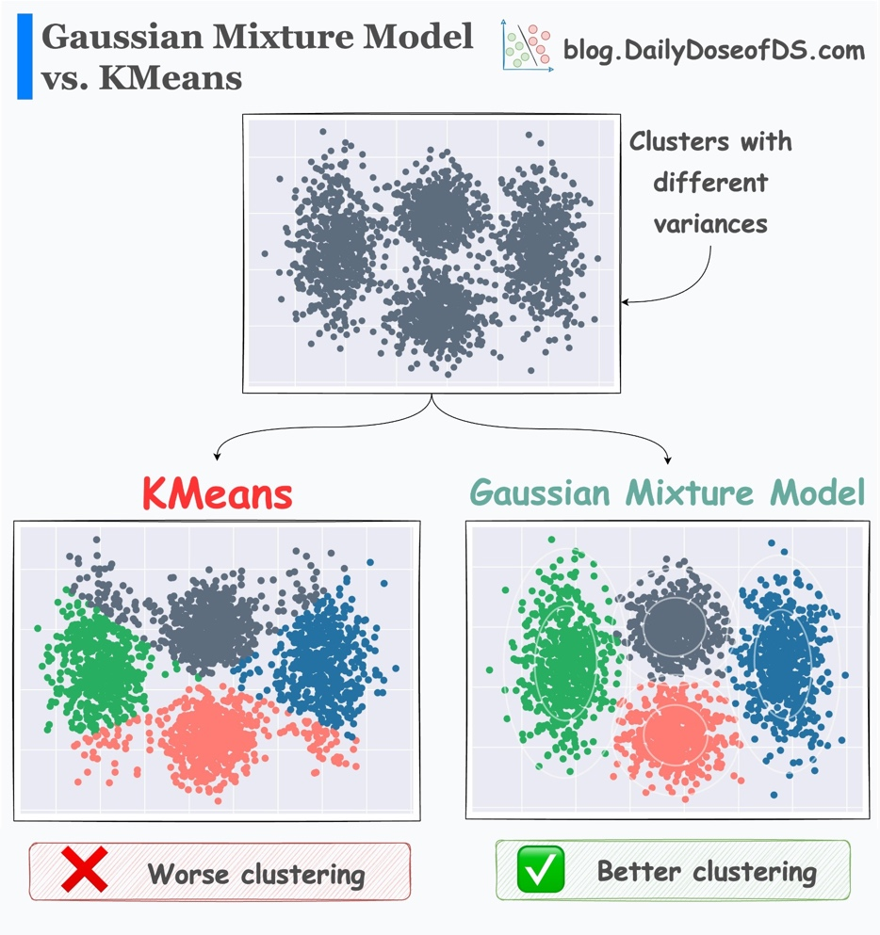
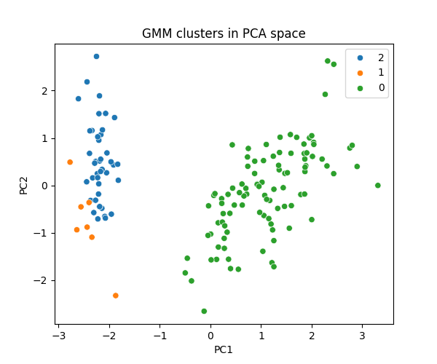
[Rationale]
- K-Means assumes spherical clusters with equal variance and hard assignments (each point belongs to exactly one cluster).
- GMM assumes each cluster is a Gaussian; it allows:
  - Elliptical shapes (through covariance matrices).
  - Different cluster sizes and variances.
  - Soft assignments (probabilities per cluster), which is more realistic in an overlap region (like versicolor vs virginica).
silhouette 0.45 (worse than K-Means)
ARI 0.51 (better than both K-Means variants in PCA/all-feature space, but still below petal-only K-Means)
- GMM allows elliptical clusters and different covariances, so it can tilt and stretch cluster shapes to better match the true distributions.
- That helps slightly with aligning clusters to species labels (ARI 0.51 > 0.43), especially in the versicolor–virginica overlap.
- But silhouette uses hard labels and Euclidean geometry; overlapping or elongated clusters tend to reduce silhouette, which explains the lower silhouette score.

Based on above improvments discussion, K-Means on petal-only features gives the most “species-like” clusters (highest ARI 0.89) and the cleanest geometry (silhouette 0.67)

Method | Silhouette | ARI
KMeans_all_features | 0.48 | 0.43
KMeans_petal_only | 0.67 | 0.89
KMeans_PCA_2D | 0.52 | 0.43
GMM_PCA_2D | 0.45 | 0.51

Logistic regression
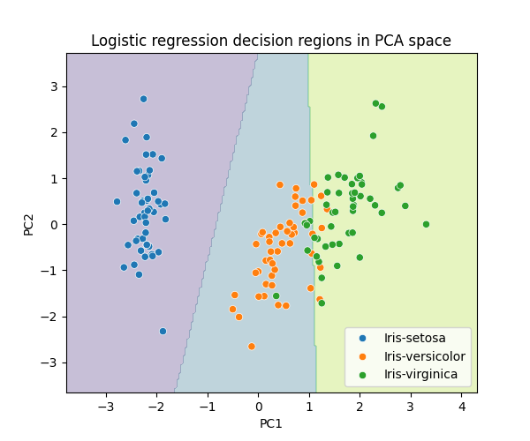

- Setosa region (left side)
  - The boundary between blue and the other colors is almost vertical and far from the blue cluster.
  - Interpretation: setosa is linearly separable from the other two species in PCA space with a large margin → classifier has very high confidence and zero errors for setosa.
- Versicolor vs virginica (middle vs right)
  - Orange (versicolor) points sit mostly in the middle region; green (virginica) points are on the right, but there is a narrow band where they mix near the decision boundary.
  - The slanted boundary between the orange and green regions cuts through this overlapping cloud.
  - these two species are almost linearly separable in PCA space, but some samples are very close in feature space, so small changes push them across the boundary → explains ≈0.93 accuracy and the misclassifications between these two classes.
- Role of PCA here
  - PCA compressed 4D features into 2D while keeping ~96% variance, so this plot is a faithful geometric view of the problem.​
  - The fact that straight lines can separate the colored regions well shows why a simple linear model (logistic regression) works so well on Iris.

